Press information

St Martin Tower: The shining jewel of the Frankfurt skyline
St Martin Tower marks a huge step forward in the development of the Frankfurt office scene, both in terms of the architecture and the lighting solution. This is where LED luminaires from Zumtobel systematically provide coordinated light at the workplace and help create an inspiring atmosphere throughout the building.
Dornbirn, November 2015 – St Martin Tower was officially opened at the start of July 2015. The subtle combination of elegance of design and lightness of construction give the building an imposing prominence, whilst also helping it blend perfectly with the famous Frankfurt skyline. Architects msm meyer schmitz-morkramer designed this office complex with a tower and a U-shaped wing, brought together around a spacious central plaza. St Martin Tower at Katharinenkreisel, the former "Opel-Rondel" (Opel Roundabout), heralds a new era of office architecture, impressing with both its purist design language and a genuine commitment to active social responsibility.
For Georg von Opel, Chairman of the Board of Directors of the Swiss corporation Hansa AG, "Corporate Social Responsibility" is one of the most important issues, if not the most decisive factor, for the future competitiveness of companies. Experience shows that a pleasant environment improves the motivation, efficiency and health of employees. As a result, from the very beginning, Georg von Opel wanted to build much more than simply an aesthetically pleasing high-rise building. His mission was to oversee a project that genuinely meets modern requirements for sustainability and quality of life in the workplace.
This approach has seen the project, which has already been pre-certified with a silver award from the German Sustainable Building Council (Deutsche Gesellschaft für nachhaltiges Bauen, or DGNB), take on a pioneering role in a host of key areas. Traditional priorities such as functionality and task-oriented spaces now share equal weighting with new aspects like optimised working environments and the associated wellbeing of people who use the building. The lighting concept, incorporating a complete LED solution from Zumtobel, and the comprehensive range of services on offer, including childcare and a fitness centre, make a significant contribution to the achievement of these objectives.
Built by Immo Hansa Beteiligungsgesellschaft mbH, this office complex meets the highest standards of architecture, design and quality. Just like the Bishop Saint Martin of Tours, from whom the building takes its name, the building is divisible, straightforward and open. The shape of the tower was driven by a fundamental desire to achieve maximum exposure to light and the best possible efficiency. The minimised core of the structure and the resulting lean segmentation ensure optimised office depths and long window clusters. This in turn means that the elegant and vertically oriented light metal facade, housing 18 office floors with a total of 17,740-square-metres of rentable space, contains a large number of workplaces close to a window. Each floor is largely devoid of supporting pillars and offers an area of almost 1000-square-metres that can be divided up into three separate units. Opal light channels embedded in the walls with integrated intercom facilities give the elevator lobbies a distinct air of elegance and PANOS infinity LED downlights help spread a pleasant lighting atmosphere throughout the hallways.
A variety of office layouts are possible. Classic individual offices offer scope for creative freedom and the utmost privacy, whilst open-plan offices encourage team-oriented cooperation and can be supplemented by designated quiet zones to promote communication and recreation. Young companies should be especially attracted to the creative office environment, where efficient working practices and productivity are combined with fun, recreation and spontaneity.
However, this kind of flexible interior design naturally places high demands on the lighting solution, which was developed by the architects msm meyer schmitz-morkramer in cooperation with Zumtobel. The SEQUENCE LED luminaire gives users the opportunity to appreciate both ergonomic glare-free direct light on the workplace and indirect light on the ceiling, creating a pleasant all-round atmosphere. The refined appearance of SEQUENCE on the silver mounting rail also adds an attractive aesthetic element, which is further enhanced by cool light with a colour temperature of 4000 K. This additional design aspect further complements the sophisticated character of the interior.
The customised SEQUENCE track, from which three or five of the slim 25mm-flat LED modules are installed on the suspended mounting rail, also guarantees the necessary flexibility required for new tenants or future redevelopment. The energy efficiency achieved during use is equally important. This task is expertly handled by the LUXMATE LITENET lighting management system, linked to discrete presence detectors in the mounting rail and a daylight sensor on the roof of the building. The amount of artificial light required is directly dependent on how much daylight is available, so that when people are present in an office, exactly the right light level is achieved for every visual task. In addition, to minimise the input of heat, blinds are adjusted automatically according to the position of the sun. Despite an array of automated features, employees can still individually adapt the lighting situation to reflect their personal needs. For this purpose, in line with the concept of maximum flexibility, wireless EnOcean switches can be mounted anywhere in the application.
The exquisite lighting solution is not just all about the interior – it also adds a welcoming level of visibility to the building when the sun goes down. The SEQUENCE track has been installed on all floors of the tower, as well as in the 7-storey core of the development with 7,536-square-metres of rentable space. The clever use of proportion, materials and a vertically oriented facade unite the different parts of the building during the day, whilst at night the lighting solution creates a harmonious and engaging blend between the tower and the wide U-shaped core.
The generously proportioned external plaza, intended as a central location for communication and exchanges, has an internal equivalent in the form of the foyer. Spanning two storeys with a marbled dark grey natural stone floor, this imposing area is illuminated by a series of PANOS infinity LED downlights. Step inside and the eye is inevitably drawn to a mosaic of the austere monk St Martin, the namesake of the project, which is beautifully showcased with DIAMO wallwashers. The reception desk, where DIAMO LED downlights also feature, is more than just about controlling access. It is designed to be an initial contact point for all kinds of interaction, such as where tenants and even external parties can reserve one of the eleven conference and meeting rooms. Windows stretching from floor to ceiling flood the interior with daylight, generating a bright and friendly impression. The elegant decor and furnishings, together with the latest media technology, combine to offer a sophisticated infrastructure for seminars and events - from one-on-one meetings to large gatherings with up to 70 people. The atmosphere in the conference rooms is perfectly enhanced by the lighting solution. A black light channel forms an elegant contrast to the parallel silver-coloured louver ceiling. CARDAN LED recessed luminaires, mounted at specified intervals, can be swivelled though 30 degrees. Only the light makes a statement, thanks to the unobtrusive design language of the fitting itself, and the warm 3000 K colour temperature nicely complements the wood of the wall panels and tables, as well as the leather chairs. As with the blinds, the CARDAN LED fittings are controlled using the LUXMATE LITENET lighting management system. Optimised lighting scenes for events such as presentations, meeting or celebrations are pre-programmed and can be intuitively selected using the media controls.
The foyer leads onto a modern 600-square-metre gastro-experience world with integrated coffee bar. The attractive contemporary interior, characterised by a clear design awash with warm tones of grey and brown and dashes of bright turquoise, looks more like a modern hotel lounge than a traditional staff canteen. In line with the rest of the building, employees and visitors are welcomed during the day by an open and light-filled atmosphere. In the darker hours, special versions of the multi-functional SUPERSYSTEM LED lighting tool add to the ambience with its unique charm, in combination with LED spotlights in the black lacquered profiles that have been installed between the perforated aluminium fins of the ceiling structure. Once again, the brilliant lighting effect takes centre stage and the subtle lines of the SUPERSYSTEM product itself remain very much out of shot.
The lighting concept designed by architects msm meyer of schmitz-morkramer with Zumtobel is the foundation of the whole St Martin Tower complex. Close collaboration between the likes of K. Dörflinger Gesellschaft für Elektroplanung mbH & Co. KG from Allendorf (electrical engineering) and EGT Gebäudetechnik GmbH from Triberg (building technology) enabled efficient and effective realisation of the initial plans. Offices, childcare facilities, a fitness centre, ancillary rooms and an underground car park - many aspects united by one impressive lighting solution using LED luminaires from Zumtobel.
Captions:
(Photo Credits: HGEsch Photography)
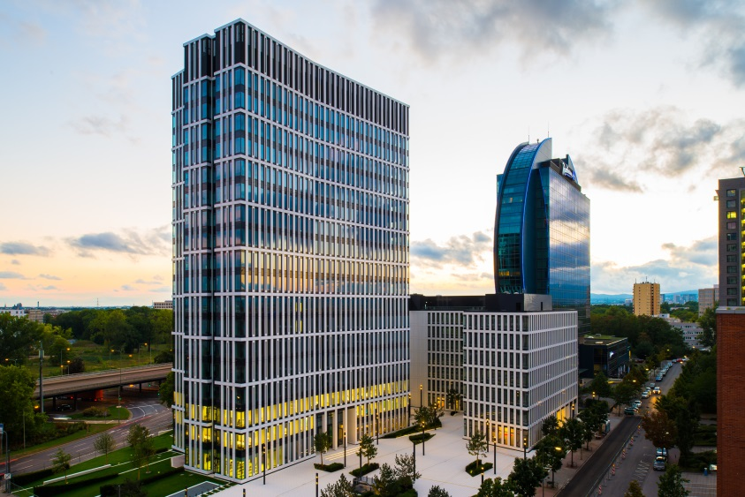
Fig. 1: The St. Martin Tower, comprising a wing-shaped tower and a U-shaped wing, heralds the start of a new era of office architecture in Frankfurt am Main.
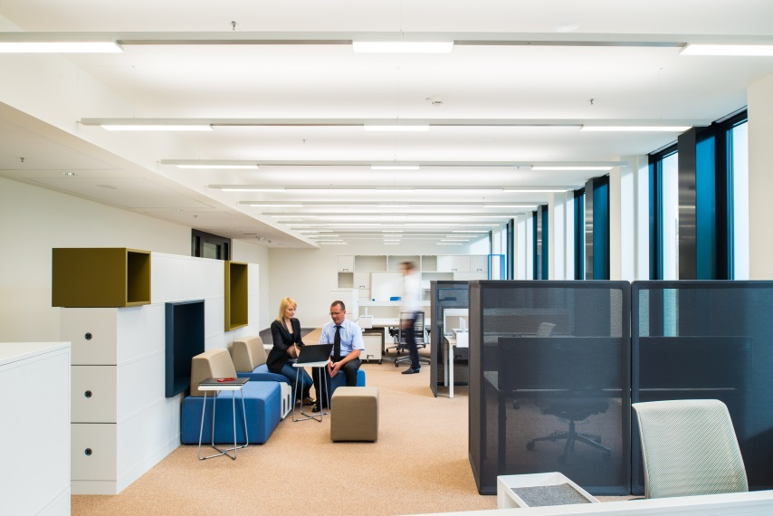
Fig. 2: The SEQUENCE track custom solution, with LED modules mounted on suspended tracks, as required, creates a pleasant room ambience.
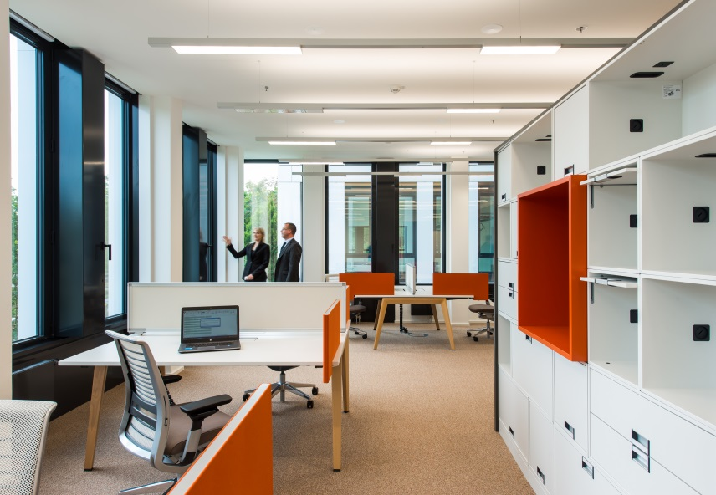
Fig. 3: Either three or five of the SEQUENCE track LED modules, which are only 25 mm in height, can be mounted on the suspended tracks, as required.
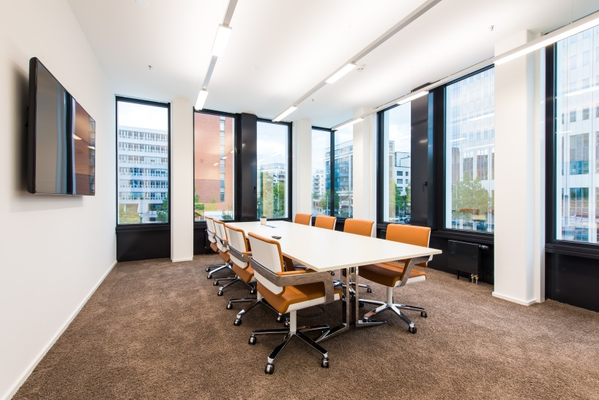
Fig. 4: Energy efficiency is equally important: LUXMATE LITENET does the job, using nearly invisible track-mounted presence detectors and a daylight measuring head installed on the roof.

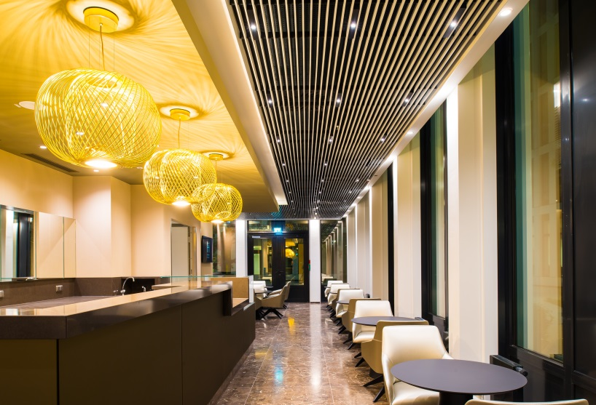
Fig. 5: The interior design of the Tower's restaurant area with its clear stylistic idiom is reminiscent of a contemporary hotel lounge rather than of a conventional staff canteen.

Press contact:
Zumtobel Lighting GmbH
Sophie Moser
Head of Brand Communications
Schweizer Strasse 30
6850 Dornbirn
Austria

Tel: +43 5572 390 26527
Mobil: +43 664 80892 3074
press@zumtobel.com

www.zumtobel.com

Responsible sales office:
ZG Licht Süd GmbH
Solmsstr. 83
60486 Frankfurt
Germany

Tel: +49 69 26 48 89 0
Fax: +49 69 69 26 48 89 80
info@zumtobel.de

www.zumtobel.de

Sales contact:
Zumtobel Lighting Ltd.  Chiltern Park  Chiltern Hill, Chalfont St Peter  Buckinghamshire SL9 9FG  United Kingdom  Tel: +44 1753 482 650  Fax: +44 1753 480 350  uksales@zumtobel.com  www.zumtobel.co.uk | Zumtobel Lighting Inc.  3300 Route 9  Highland , NY 12528  United States  Tel: +1 845 691 6262  Fax: +1 845 691 6289  zli.us@zumtobelgroup.com  www.zumtobel.us

For further contact details in further sales regions please visit: http://www.zumtobel.com/com-en/contact.html

About Zumtobel
Zumtobel, a leading international supplier of integral lighting solutions, enables people to experience the interplay of light and architecture. As a leader in innovation, Zumtobel provides a comprehensive range of high-quality luminaires and lighting management systems for professional interior lighting in the areas of offices, education, presentation & retail, hotel & wellness, health, art & culture as well as industry. Zumtobel is a brand of Zumtobel Group AG with its head office in Dornbirn, Vorarlberg (Austria).
Zumtobel. The Light.

