Press Release

Zumtobel part of the game at the new DFB museum
Under the motto "We are football", the German Football Association (DFB) has created a museum that offers its visitors an innovative, multimedial and contextually sophisticated experience. A lighting solution from Zumtobel, the LUXMATE LITENET lighting management system, is a key player that will meet the scenographic and emotional expectations.
Dornbirn, June 2016 – The 2016 European Championship currently has a firm grip on Europe and the German national team are well on the way to writing another chapter of football history. Since October 2015, the German Football Museum in Dortmund has been the home of unforgettable footballing moments in Germany. The exhibition is spread over 3,300 m² and impresses with a modern concept that offers visitors a high-quality experience with interactive and multimedial content. With an exciting sequence of rooms and variety of materialisation, the diverse dramaturgy naturally demands the right lighting concept that on the one hand highlights certain elements, e.g. to accentuate the national team's gleaming trophies, and on the other hand guides people specifically through the rooms. Moreover, light also plays an important emotional role, not just when informing different generations and inspiring reflection, but to surprise, touch and inspire them and, last but not least, to entertain them.
With this in mind, Zumtobel convinced the contractors, architects and planners with their competence in the area of lighting control and was awarded the contract for a large part of the museum's interior lighting. The key lighting solution is the flexible lighting management system LUXMATE LITENET, which enables the luminaires' luminous intensity and colour temperature to be independently defined and adjusted – the right lighting scenario can be configured for the respective area of application. Moreover, it provides integration with the emergency escape lighting using the emergency lighting system ONLITE, which is used throughout the entire building. General lighting is taken care of thanks to the TECTON continuous-row luminaire, PANOS downlights and Cardan E1 gimbal-mounted luminaire modules, conciliating efficient lighting with great light quality and ideal colour rendering. In staircases and passages, the aesthetic Sottile light line, a project luminaire based on the SLOTLIGHT infinity slim, emphasises subtle accents and ensures and an excellent atmosphere in the room in which visitors feel at ease.

Image captions:

(Photo Credits: Zumtobel)
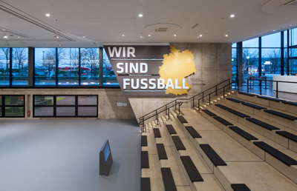
Figure 1: DFB museum entrance area: CARDAN recessed luminaires have been built into the ceiling here.
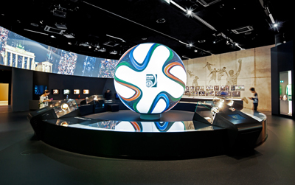
Figure 2: THE TECTON continuous-row system (see ceiling) are in use as general lighting at the German Football Museum.
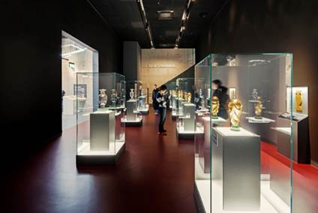
Figure 3: The LUXMATE LITENET lighting management system offers a wide range of functions to fulfil the requirements and the dramaturgy of a modern museum concept.
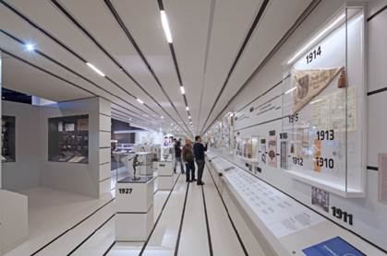
Figure 4: The Tecton continuous-row system provides effective accents and creates an inviting ambience for visitors.
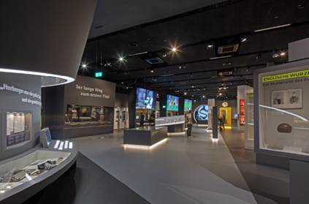
Figure 5: The German Football Museum is designed for multifunctionality, therefore the lighting solution is characterised by flexibility and compatibility with other systems.
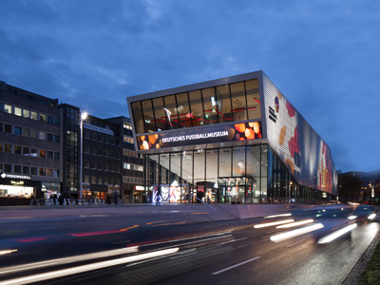
Figure 6: Since October 2015, the German Football Museum in Dortmund has been the treasure chamber of unforgettable footballing moments in Germany.

Press contact:
Zumtobel Lighting GmbH  Andreas Reimann  Brand PR Manager  Schweizer Strasse 30  6850 Dornbirn  Austria  Phone: +43 5572 390 26522  press.zumtobel@zumtobelgroup.com  www.zumtobel.com | Zumtobel Group  Jennifer Sewell  Marketing Communications Manager  Chiltern Park, Chiltern Hill  Chalfont St Peter, Buckinghamshire SL9 9FG  United Kingdom  Phone: +44 0 7785 232 294  jennifer.sewell@zumtobelgroup.com  www.zumtobel.com
Zumtobel Lighting Inc.
Karianna Haasch
Marketing Manager Americas
Zumtobel Lighting US
3300 Route 9W
Highland, NY 12528
Phone: +1 845-691-6262 - 7611
karianna.haasch@zumtobelgroup.com
www.zumtobel.us

About Zumtobel
As a leader in innovation, Zumtobel develops sustainable lighting solutions tailored to the needs of people in their respective applications. With a comprehensive portfolio of high-quality luminaires and intelligent lighting management systems, the Austrian company provides optimum indoor and exterior products for working and living spaces - the right light for every activity at any time of day. The applications office, education, presentation and retail, hotel and wellness, health, art and culture and industry are now perfectly complemented with portfolios for living and outdoor areas. Zumtobel is a brand of Zumtobel Group AG with its head office in Dornbirn, Vorarlberg (Austria).
Zumtobel. The Light.

