Press release

Experiencing tradition in a new way thanks to cutting-edge technology
Reform Club in London counts on a Zumtobel lighting solution

The Reform Club is both internally and externally of one period and is one of the most important buildings in London dating back to the Victorian period. A visit to the Reform Club is a special experience even today. The primary goal of the lighting solution was to add life, excitement and vitality and provide the ‘eyes’ through which to the Victorian-age building's charisma and provide a pleasant and unforgettable atmosphere for both visitors and staff, while at the same time meeting conservation and energy requirements.

London, February 2014 – The long-established Reform Club is situated in the heart of London`s Clubland. Its founders commissioned Sir Charles Barry, at the time one of the most renowned architects, to design an ‘imposing and Palatial Clubhouse’ which opened in 1841. The original decorative finish of the Victorian-age building has been undergoing delicate conservation and restoration and it is considered one of the most important “Grade 1 historic listed interiors in London. From the outset, a clear client vision and concept was to introduce life back into the Grand Hall, with its galleried landings and wonderful Atrium. The lighting was to be ‘The Eyes’ through which to enjoy this internationally important Grade 1 listed historic interior, providing a soft warm three dimensional glow bringing architectural details, artworks and paintings to life.
The Bristol-based “Lighting Services” worked closely with the client to deliver a lighting solution which has received acclaim "English Heritage is delighted with the scholarly programme of restoration and conservation work at the Reform and considers that its outstanding interiors are greatly enhanced by the lighting scheme adopted". Zumtobel was chosen as the appropriate partner to provide the concept led technologically advanced lighting and control systems. Product design fulfilled the requirements in terms of efficiency, sustainability and flexibility which played a role in delivering the final outcome.

Based on Zumtobel`s intelligent Luxmate Litenet lighting management system, ‘Lighting Services’ were able to develop an innovative lighting concept that provided adaptable multiple DALI LED spotlights which cross washed 18 listed portraits and once dark and out of sight, the splendid coffered ceilings, swags and pilaster capitals are now vibrant and alive. The columns are set in relief providing a wonderful overall balanced visual effect to what is in essence a fabulous stage set. Thanks to the system's compatibility, the lighting solution can be adjusted as required and can also be extended to incorporate other areas and fittings.

Daylight-based control increases comfort and efficiency
Since the building is used 24/7, potential energy savings had to be identified and realised to optimum extent. This sustainable lighting solution is based on the perfect interplay of state-of-the-art LED technology and innovative luminaires with intelligent lighting management as its centrepiece: the Luxmate Litenet lighting management system combines complex system features such as use of daylight, presence detection, integration of emergency lighting, and predefined room profiles in one central unit that is easy to operate. The external daylight sensor installed on the roof continuously monitors incoming daylight, thus optimising the use of daylight. In every room, just the quantity of artificial light is added that is required to achieve optimum lighting conditions.
In addition, Luxmate Litenet provides a high degree of flexibility, which was the decisive factor for its use at the Reform Club. As the lighting system will be refurbished step by step in other areas and rooms as well, the client requires the system to be easily extendable in the future. Using pre-programmed scenarios, Luxmate Litenet also provides the opportunity to easily and conveniently create appropriate atmospheres for a variety of social gatherings and other events in the areas designated for this purpose.
As the heritage requirements dictated that the light source should not be visible for the most part, the minimalist Supersystem LED lighting system was used in all areas, both on the ground floor and the first floor. Thanks to its pared-down design, Supersystem blends unobtrusively into the architecture, enhancing it to optimum effect. The high-power LED spots cannot fail to impress on account of their modularity, since lighting inserts for direct and indirect lighting can be flexibly placed next to each other within one module, which allows them to tackle a variety of different lighting tasks easily. In the atrium, the lighting solution is complemented by DALI LED Decoline and Discus LED spotlights. They set the lighting stage for the impressive “sun-burner”, an oversized historic gas lantern formerly used for illumination and heating.
With the lighting required – both by the Client’s concept and heritage constraints – to be in relatively inaccessible locations the life and location of components and the cost of their maintenance and component replacement was a key factor. The traditional lighting had required a visual manual check on failed bulbs and their regular and frequent replacement.

About the Reform Club
The impetus for the establishment of the Reform Club was the Great Reform Act of 1932. The Club is in the heart of London’s Clubland. Established in 1836 by the Whigs and the Radicals the club later became the home of the Liberal party. It is now without any affiliations to any political party. The Club is well respected worldwide and is at the hub of an international membership and provides a significant and varied intellectually challenging programme. The link with the past enhanced by the magnificent architecture of Sir Charles Barry provides a brilliant and inspiring stage set in which to host the intellectual and social life of the Club.
Please visit www.lightingservices.com&www.reformclub.com
For a visual tour please visit: http://www.sphericalimages.com/reform-club-virtual-tour/
Fact box:

Lighting solution | DISCUS LED spotlights  SUPERSYSTEM LED lighting system  DECOLINE  LUXMATE Litenet lighting management system
Client | Reform Club, 104 Pall Mall, London
Lighting design | Lighting Services Ltd, Bristol
Electrical consultants / installations | CBS Maintenance Services Ltd., Dartford, Kent

Captions:

(Photo Credits: Zumtobel)

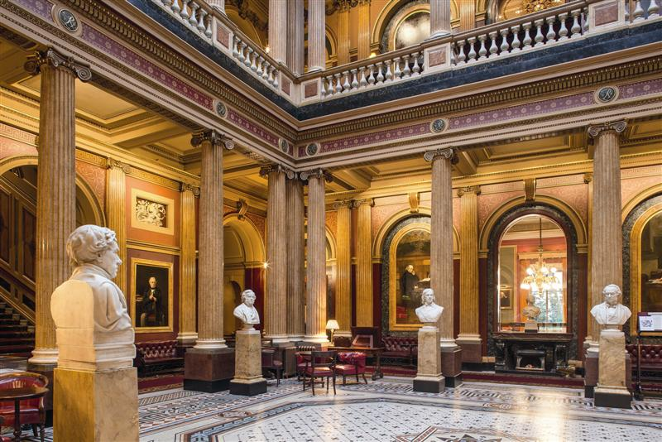

Image 1: The primary goal of the lighting solution was to add life, excitement and vitality and to the Victorian-age building's charisma and provide a pleasant and unforgettable atmosphere for both visitors and staff, while at the same time meeting conservation and energy requirements.

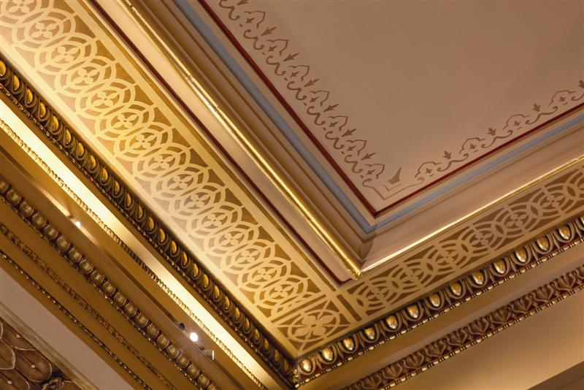

Image 2: As the heritage requirements dictated that the light source should not be visible for the most part, the minimalist Supersystem LED lighting system was used in all areas, both on the ground floor and the first floor.

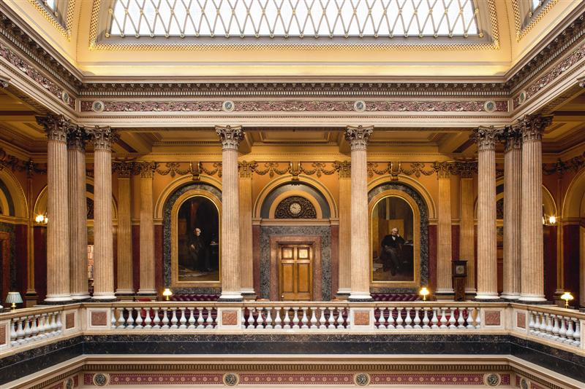

Image 3: This sustainable lighting solution is based on the perfect interplay of state-of-the-art LED technology and innovative luminaires with intelligent lighting management as its centrepiece: the Luxmate Litenet lighting management system combines complex system features such as use of daylight, presence detection, integration of emergency lighting, and predefined room profiles in one central unit that is easy to operate.

Press contact:
Zumtobel Lighting GmbH
Sophie Moser
PR Manager
Schweizer Strasse 30
A-6851 Dornbirn

Tel +43-5572-390-26527
Mobile +43-664-80892-3074
E-mail sophie.moser@zumtobel.com

www.zumtobel.com

About Zumtobel
Zumtobel, a leading international supplier of integral lighting solutions, enables people to experience the interplay of light and architecture. As a leader in innovation, Zumtobel provides a comprehensive range of high-quality luminaires and lighting management systems for professional interior lighting in the areas of offices, education, presentation & retail, hotel & wellness, health, art & culture as well as industry. Zumtobel is a brand of Zumtobel AG with its head office in Dornbirn, Vorarlberg (Austria).
Zumtobel. The Light.

