Press release

Green building's energy efficiency is enhanced by lighting
Zumtobel lighting solution installed in first building with LEED platinum certification in Germany, Austria and Switzerland

Dornbirn, October 2013 – The new headquarters of the Lauterach-based i+R Group (formerly i+R Schertler-Alge) with its long-standing tradition is considered a showcase project for sustainable building. On 9 October 2013, it obtained LEED Platinum and is now the first corporate building in Germany, Austria and Switzerland featuring this certification - and the only one so far. The highest level of LEED green building certification was awarded in the category “New Construction & Major Renovations”. Zumtobel made an essential contribution to implementing the clients' ambitious targets by providing an integrated lighting solution which scored not only in terms of efficiency, but also on account of its flexibility and user comfort.

Intelligent use of daylight in the entire building
The use of daylight plays a vital role in the entire building. Although one aim is to increase efficiency, the main goal is to create perfect working conditions for the staff, explains i+R Managing Director Reinhard Schertler: “For our new i+R headquarters, our top priority was to provide our staff with the best possible ambience. An innovative artificial lighting concept that maximises the use of daylight and thus has a positive impact on our employees' well-being was therefore of utmost importance to us.”
A daylight-based control system ensures a perfect combination of daylight and artificial lighting and creates optimum lighting conditions for the staff. Changes in lighting intensity are detected by sensors in the rooms and are automatically balanced. The resulting slow increase or decrease of the lighting level is hardly perceivable to the human eye. Despite the high degree of automation, the lighting solution leaves plenty of room for individual preferences, for all staff members can adjust lighting intensity levels, incident sunlight and temperature according to their personal needs.
Using this energy-saving lighting solution largely based on LED and further supported by presence detectors, the i+R Group was able to cut lighting-related energy consumption by up to 70 percent. In collaboration with the lighting designers of the Bartenbach Lighting Laboratory, Zumtobel managed to develop a lighting solution that provides a high degree of flexibility based on cutting-edge technology. Thus, it meets not only the specific needs of the i+R Group and complies with the high standards placed on LEED Platinum certified buildings, but is also sufficiently compatible and adjustable to fulfil the highest requirements in terms of sustainability and comfort in the long term.

Transparency thanks to environmental product declarations (EPD)
Zumtobel is the first company in the lighting industry to introduce environmental product declarations in compliance with the international ISO 14025 and EN 15804 standards. These so-called EPDs document the environmental impact of a product throughout its life cycle, for instance in terms of CO₂ balance, recycling percentage, material composition or recyclability. In particular when it comes to building certification standards such as LEED, EPDs ensure the necessary transparency and are an essential component of the certification process.
In addition, Zumtobel supports its partners and customers during the building certification process by providing in-house experts for green building. Thanks to their comprehensive know-how, they are able to give valuable advice regarding the development of a sustainable lighting solution, in particular with respect to the different certification processes.

About LEED
LEED* (Leadership in Energy and Environmental Design) is an internationally recognised certification system for sustainable building. Besides environmental and economic aspects, it evaluates socio-cultural criteria such as room climate and workplace quality, but also attractiveness of location and technical innovations in design and implementation.

Fact box
Lighting solution: | Custom LED lighting solution
Client: | i+R Group, Lauterach
Architects: | Dietrich und Untertrifaller
Lighting design: | Bartenbach Lighting Laboratory

Captions
(Photo credits: Zumtobel)
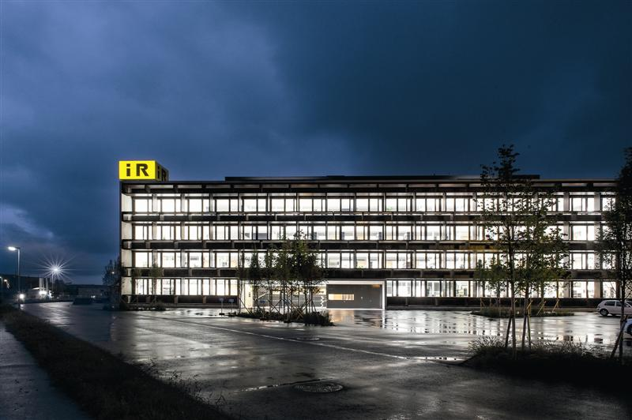
Caption 1: The i+R Group headquarters is the first LEED Platinum certified building in Germany, Austria and Switzerland.

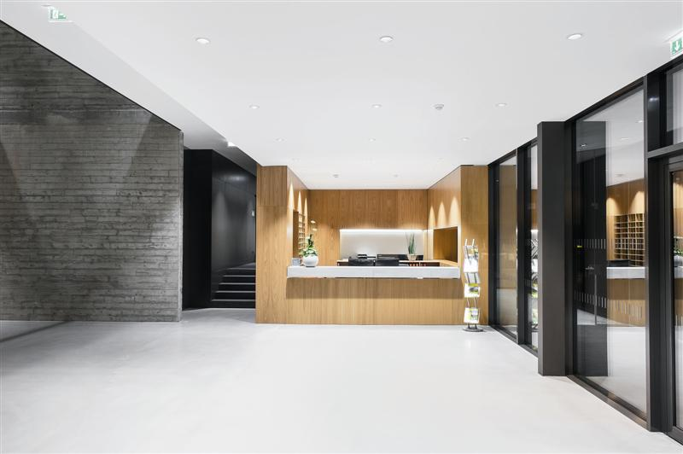
Caption 2: Zumtobel made an essential contribution to obtaining the certification by providing an integrated lighting solution.
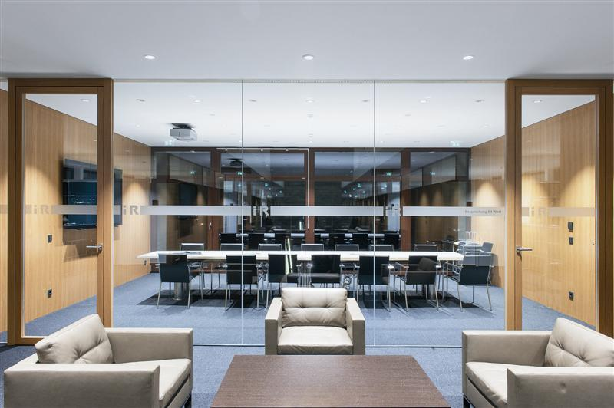
Caption 3: A daylight-based control system ensures a perfect combination of daylight and artificial lighting and creates optimum lighting conditions for the employees.

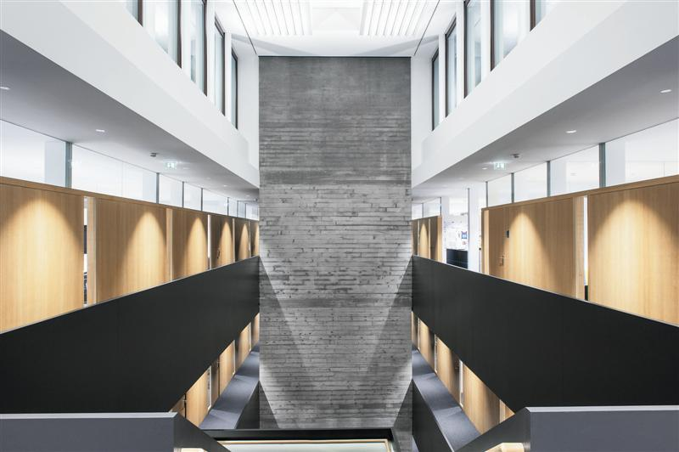

Caption 4: Using this lighting solution largely based on LED and further supported by presence detectors, the i+R Group was able to cut lighting-related energy consumption by up to 70 percent.

For more information, please contact:
Zumtobel Lighting GmbH  Sophie Moser  PR Manager  Schweizer Strasse 30  A-6851 Dornbirn  Tel +43-5572-390-26527  Mobile +43-664-80892-3074  E-mail sophie.moser@zumtobel.com  www.zumtobel.com | Zumtobel Lighting GmbH  Daniel Lechner  Marketing Director Austria & CEE  Donau-City-Strasse 1  A-1220 Vienna  Tel. +43 (1) 258 26 01 82875  Fax +43 (1) 258 26 01 982875  E-mail daniel.lechner@zumtobel.com  www.zumtobel.at

About Zumtobel
Zumtobel is a leading international supplier of integral lighting solutions that enable people to experience the interplay between light and architecture. As a leader in innovation, Zumtobel provides a comprehensive range of high-quality luminaires and lighting management systems for a wide variety of professional interior lighting applications – including office and education, presentation and retail, hotel and wellness, health and care, art and culture and industry. Zumtobel is a brand of Zumtobel AG with its head office in Dornbirn, Vorarlberg (Austria).
Zumtobel. The Light.

