Press release

LED lighting solutions meeting individual needs
A global user study conducted by Zumtobel and Fraunhofer IAO has shown that office users prefer colour temperatures in the range between 3000 K and 6000 K. Against this background, Zumtobel has added tunableWhite technology to its range of office luminaires.
Dornbirn, November 2014 – The global user study on lighting quality perceived in offices conducted by Zumtobel and Fraunhofer IAO has shown that office users' preferences with regard to colour temperature differ very much. The range of colour temperatures perceived as ideal is usually between 3000 K and 6000 K, with a clearly marked majority preference for 4000 K and 5000 K scenarios. The study also shows that office users rate their situation at work significantly higher where it is possible for them to adjust the lighting to their needs. However, 57.4 per cent of those surveyed, i.e. more than half of them, have no influence – or only to a limited extent – on lighting control and therefore cannot optimise the lighting situation accordingly. A factor that has a major impact on people's sense of well-being and consequently their satisfaction at the workplace. As continuously colour temperature-adjustable LED luminaires cater for these individual user needs the most effectively, Zumtobel has added tunableWhite technology to its range of luminaires.
LIGHT FIELDS evolution tunableWhite
Zumtobel meets users' various requirements by providing a lighting solution that combines innovative LED technology with sophisticated design quality. Thanks to tunableWhite technology, users can adjust the colour temperature of the LIGHT FIELDS evolution LED luminaire range continuously between 3000 K and 6000 K. The LED luminaire range uses a consistent design language. From recessed and surface-mounted through to free-standing or pendant luminaires: each luminaire incorporates a specifically developed brilliant optic. For the user this means that LIGHT FIELDS evolution featuring tunableWhite technology not only adjusts colour temperature to meet individual requirements but also provides perfect lighting quality at the workstation.
MELLOW LIGHT V tunableWhite
The MELLOW LIGHT V recessed luminaire provides offices with light that is similar to daylight. The versatile recessed LED luminaire ensures gentle, glare-free light distribution without any distracting hard shadows, allowing for balanced illumination of task areas, walls and the ceiling. This creates an open, bright room atmosphere. MELLOW LIGHT V tunableWhite provides additional flexibility and customisation: the luminaire can be integrated into a lighting management system such as LITECOM in next to no time, and can be continuously adjusted in the range between 3000 K and 6000 K.
ONDARIA tunableWhite
With its opal, uniform luminous panel and circular design, ONDARIA creates a pleasant atmosphere and ensures excellent lighting quality in prestigious areas such as lobbies and foyers or in common areas. In order to adjust the lighting situation to the individual needs of users, all three design sizes (940 mm, 640 mm and 440 mm) are now available with built-in tunableWhite technology. This means that ONDARIA's colour temperature can be continuously adjusted in the range between 3000 K and 6000 K.

Captions:
(Photo credits: Zumtobel)
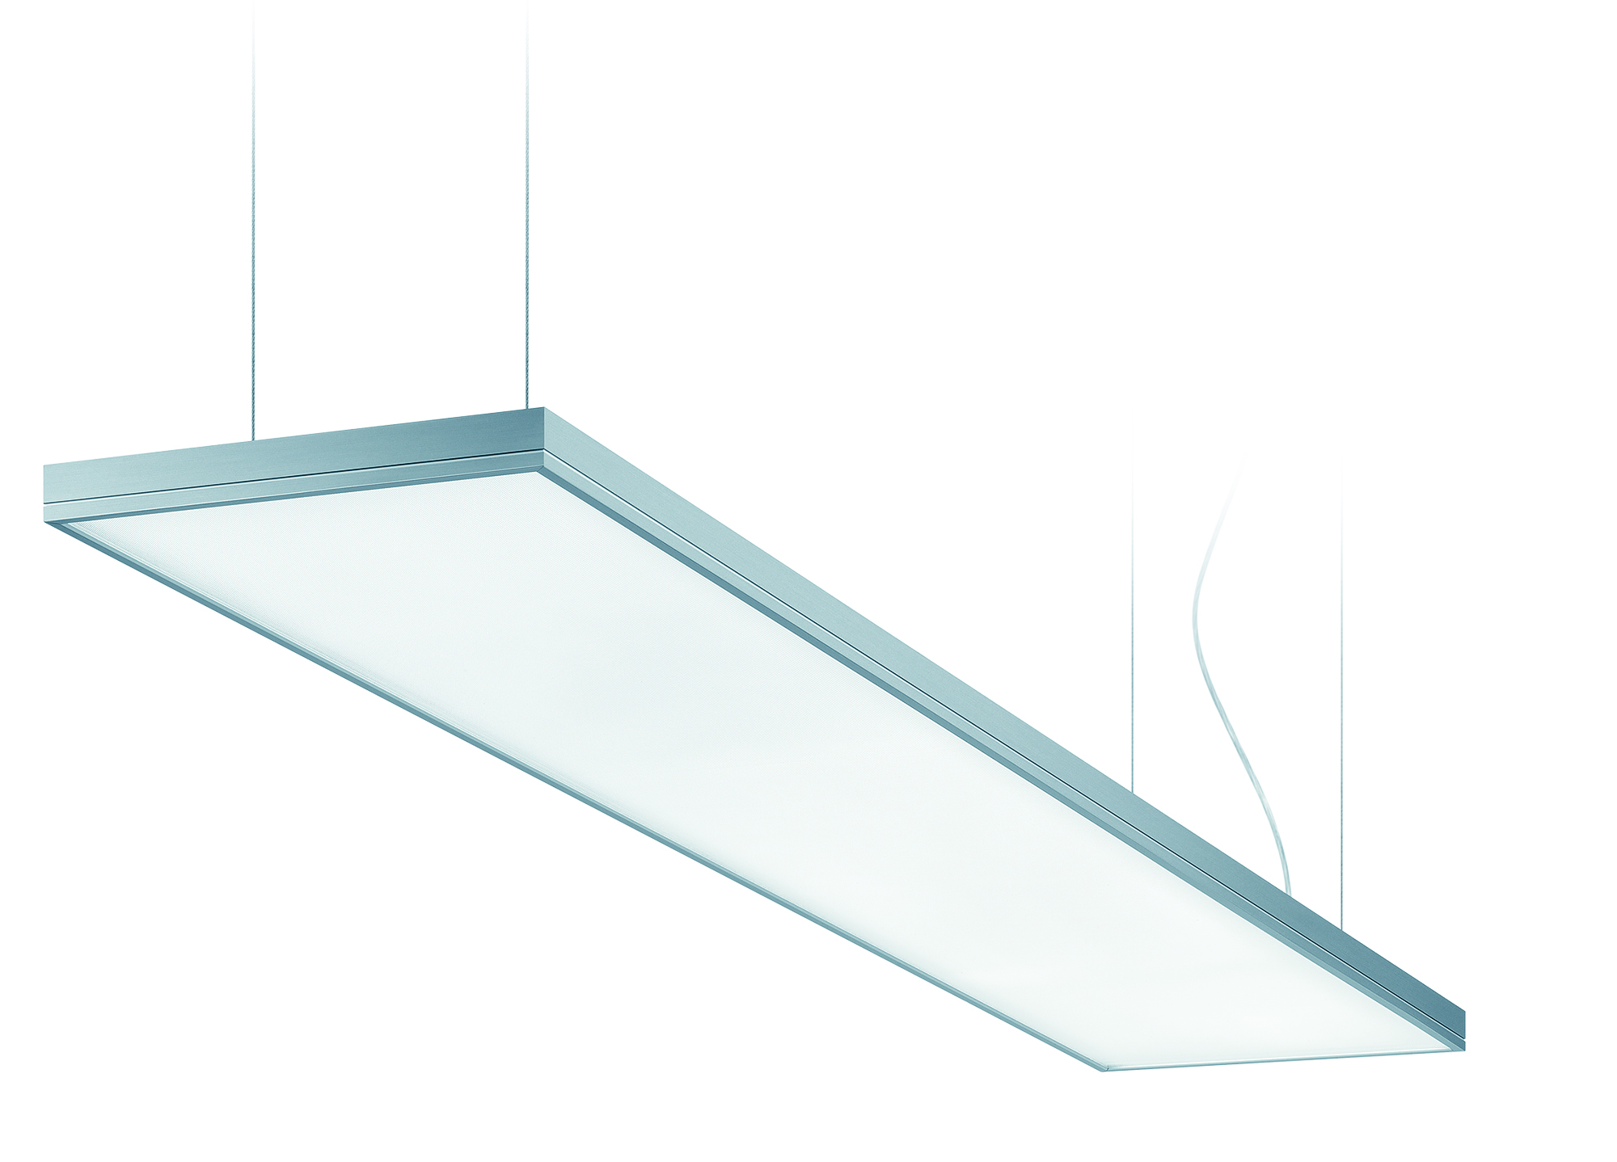
Fig. 1: LIGHT FIELDS evolution incorporating tunableWhite technology: LED luminaire range that meets individual needs
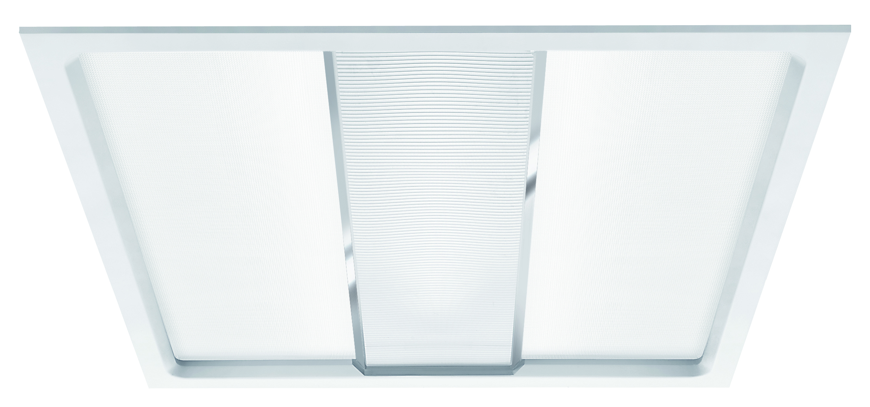
Fig. 2: MELLOW LIGHT V creates an open, bright room atmosphere. Thanks to tunableWhite technology, the luminaire provides customers with additional flexibility and customisation.
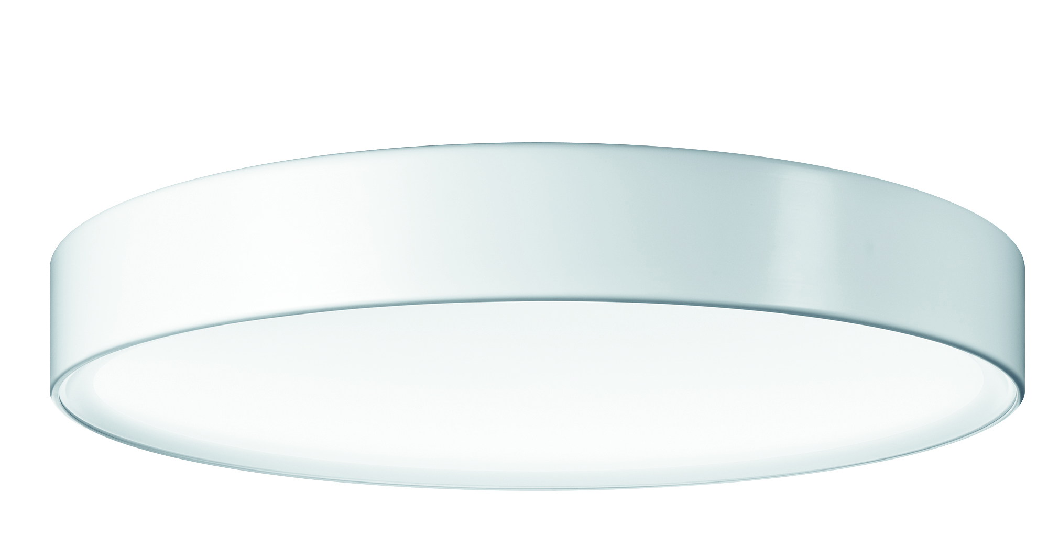
Fig. 3: In order to adjust the lighting situation to the individual needs of users, all three design sizes of ONDARIA are now available with built-in tunableWhite technology.

Press contact:
Zumtobel Lighting GmbH
Sophie Moser
PR Manager
Schweizer Strasse 30
A-6850 Dornbirn

Tel: +43-5572-390-26527
Mobil +43-664-80892-3074
E-mail press@zumtobel.com
www.zumtobel.com

Sales contact:
Zumtobel Lighting Ltd.  Chiltern Park  Chiltern Hill, Chalfont St Peter  Buckinghamshire SL9 9FG  United Kingdom  Tel: +44 1753 482 650  Fax: +44 1753 480 350  uksales@zumtobel.com  www.zumtobel.co.uk | Zumtobel Lighting Inc.  3300 Route 9  Highland , NY 12528  United States  Tel: +1 845 691-6262  Fax: +1 845 691-6289  zli.us@zumtobelgroup.com  www.zumtobel.us

For further contact details in further sales regions please visit: http://www.zumtobel.com/com-en/contact.html

About Zumtobel
Zumtobel, a leading international supplier of integral lighting solutions, enables people to experience the interplay of light and architecture. As a leader in innovation, Zumtobel provides a comprehensive range of high-quality luminaires and lighting management systems for professional interior lighting in the areas of offices, education, presentation & retail, hotel & wellness, health, art & culture as well as industry. Zumtobel is a brand of Zumtobel AG with its head office in Dornbirn, Vorarlberg (Austria).
Zumtobel. The Light.

